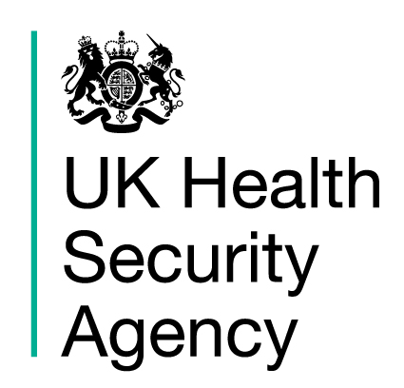
Microbiology Sample Containers:
A General Practice Field Guide

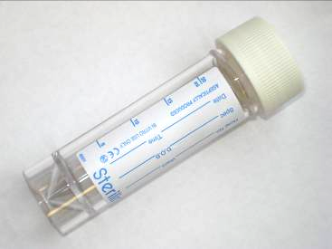 | 20ml Sterile Universal  Fluids and aspirates Sputum  Mycology samples  Urines for legionella antigens | 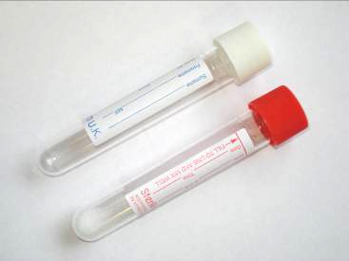 | 10ml Urine Tubes  Urines for M,C&S  Use boric red top if possible
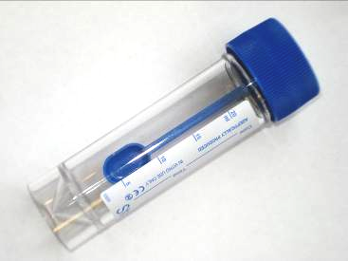 | 20ml Blue Top with Spoon  All faeces samples (5ml minimum) | 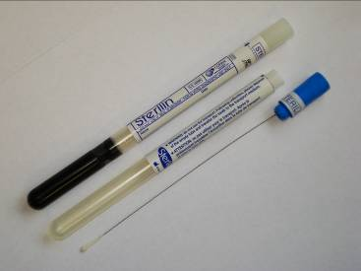 | Pernasal Swab  Pertussis PCR  Please send swab in the dry tube  Do not use the charcoal gel tube
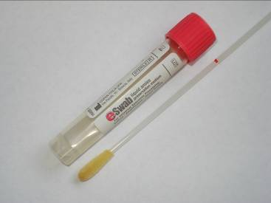 | Liquid eSwab  General M,C&S for bacteria including wounds and HVS | 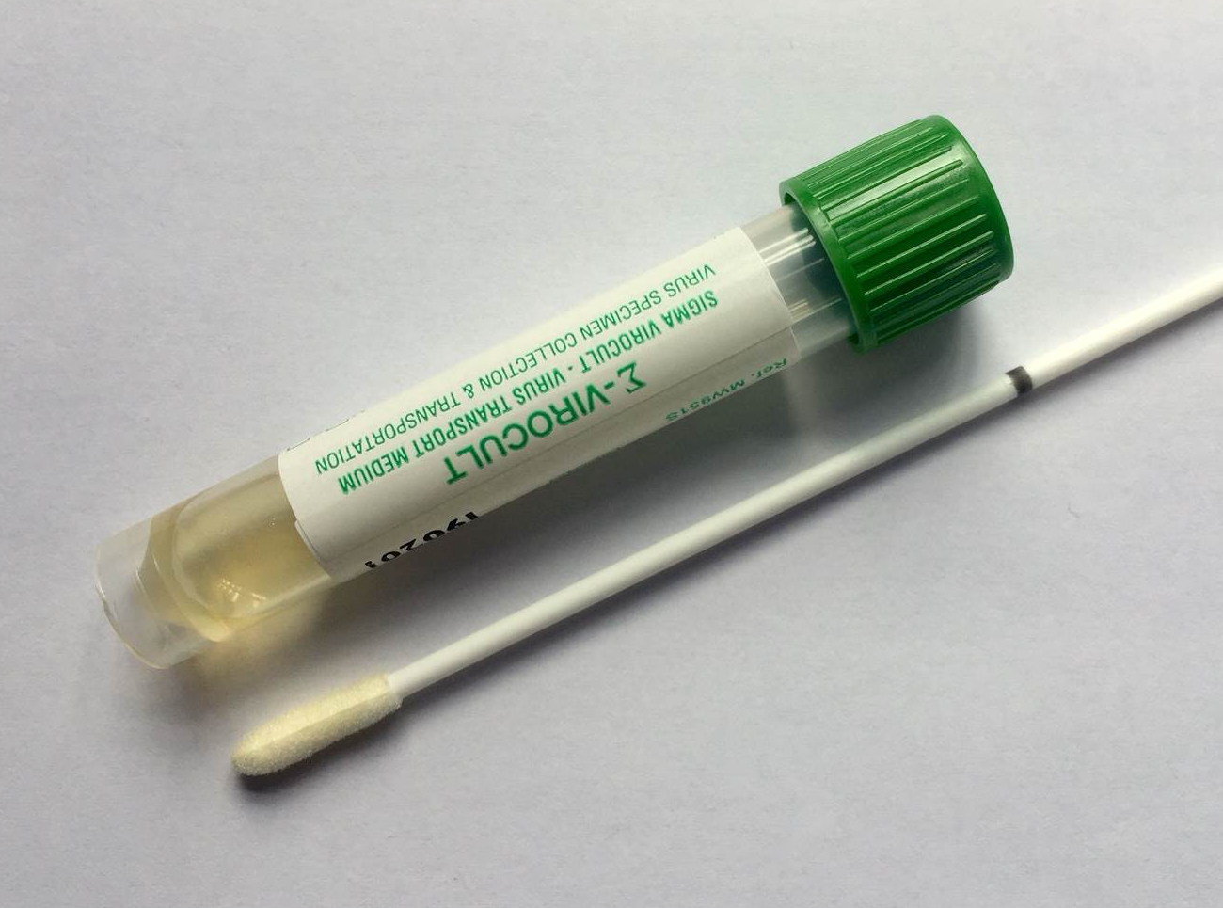 | Viral Transport Medium  All virology swabs including nose and throat swabs for respiratory viruses (e.g. flu), vesicle and genital swabs
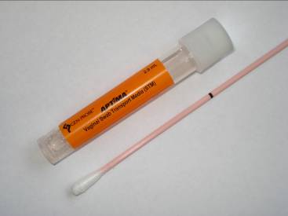 | APTIMA Swab  Chlamydia and gonorrhoea molecular test | 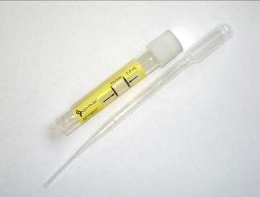 | APTIMA Urine Tube  Chlamydia and gonorrhoea molecular test
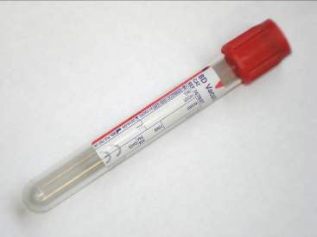 | Red Top Blood Tube for Serum  All serology tests | 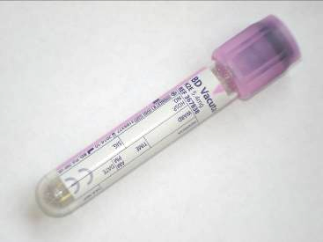 | Purple Top EDTA Blood Tube  All molecular (DNA and RNA) microbiology and virology blood tests

Please remember that all samples need to be labelled with two patient identifiers that match with those on the request form, sufficiently filled and tightly capped. Tests required and relevant clinical history should be clearly stated on the request form.

For more information visit www.heftpathology.com or call the Public Health Laboratory Birmingham on 0121 424 3111 November 2022

